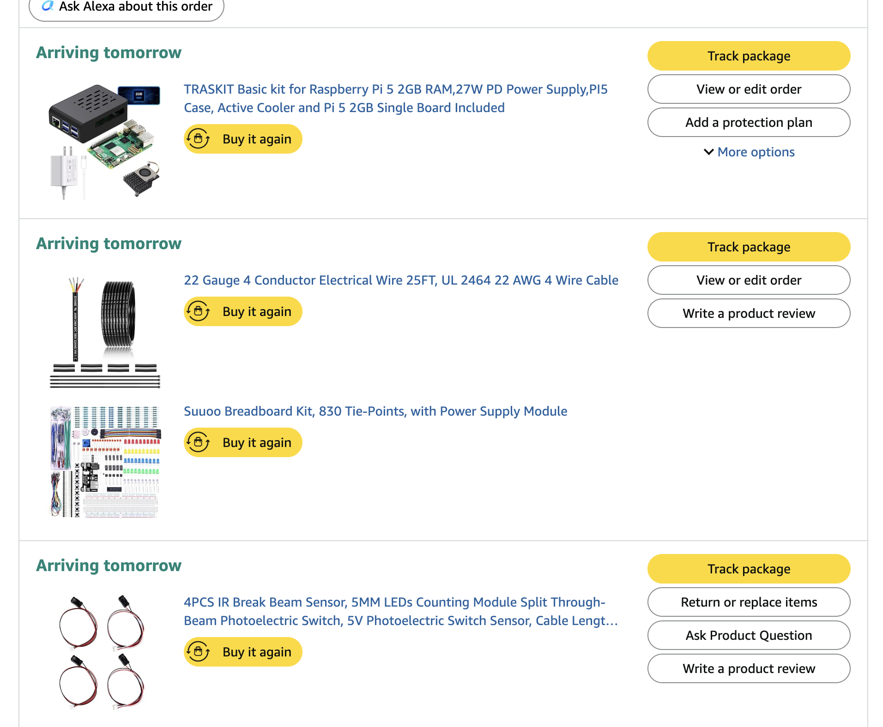

I am on a team with Cole Rechsteiner
https://github.com/Jonahht1/CS-370-Term-Project - Json transcripts available here.

Problem Memo: Doorway Passage Detector
Team: Jonah Tomarchio, Cole Rechsteiner
1. The user.
Parents of an infant, monitoring the door to their child's room in a household where other people, older children, or pets move through during the day and night.
2. The problem.
These households have no record of when the nursery door is opened, or whether it was left standing open. The door is opened many times a day by different people, and it is routinely found ajar with no way to tell whether someone entered, someone left, or the door simply drifted. The costs are concrete: a door left open lets a pet or a toddler in unsupervised, undoes the dark and quiet the room depends on, and wakes a sleeping infant, which costs the parents sleep they can't recover. Because nothing is recorded, the parents' only recourse is to get up and check, repeatedly, through the night.
3. Why a device.
This is a 3 a.m. problem by definition: the events happen while the parents are asleep or in another room, so something must be mounted at the door and continuously awake to catch them. A phone can't sense a door opening or a person crossing a threshold; it records only what someone remembers to log. Off-the-shelf contact sensors report "open/closed" and nothing more, so they can't distinguish a person entering the room from a door bumped ajar or drifting on the HVAC. A camera would answer the question but is precisely what many parents will not put in a child's room, and it still requires someone to watch it.
4. The sensors.
A wired magnetic reed switch on the door frame detects when the door opens and closes. Two 5V IR through-beam pairs mounted across the doorway, separated by a few inches, detect crossings, and the order in which the beams break gives direction (in or out). They cooperate rather than coexist:
- The reed switch opens a time window, and only beam breaks inside that window count as a passage.
- Door open with no beam break means the door drifted or was left ajar with nobody passing through.
- A beam break with the door reading closed means a fault or misalignment, which the device flags rather than counts.
Neither sensor alone separates "someone went into the room" from "the door is open." The parents' question is the first one, and answering it takes both.
5. The mechanisms.
- Interrupt handling: the reed switch and both IR beams raise hardware interrupts, so each event is captured and timestamped the moment it occurs rather than being missed between polls.
- Synchronization: sensor-handling threads write to a shared event log, which requires locking so near-simultaneous door and beam events aren't lost or recorded out of order.
6. The risk.
Counting accuracy, and what it costs this user to be wrong. Two people passing back-to-back can register as a single crossing, and the IR beams are vulnerable to misalignment and to sunlight or other IR sources in the doorway. A parent who trusts a log that quietly missed an entry is worse off than one who kept checking. We are building a record of door activity, not a safety device, and we will say so plainly. Proving the counts hold up under normal household conditions is the first thing we have to do.

